***Mini Project On***

***Passing the Pass***

**Introduction:**

Question: Create an application using circular linked list in C++ programming language.

**Answer:**

* Creating the game of musical chairs using circular linked list
* Taking input of different players in the game
* Storing and updating count of the eliminated player and the number of chairs after each round
* Implementing audio and time control through the console
* Creating a leader board at the end of the game depicting the last standing player at the very using stacks
* Implementing a ticket system to play the game i.e the user has to buy the ticket to take part in the game.

Learning: What’s new?

* Implementation of circular linked list in a unique way
* Having command over time and music played during musical chairs
* An attempt to print complex patterns using basic knowledge of various iterative loops
* Applying Concept of Stacks in an integral element of the program

***Results and discussion:***

**1)** Buy a ticket.

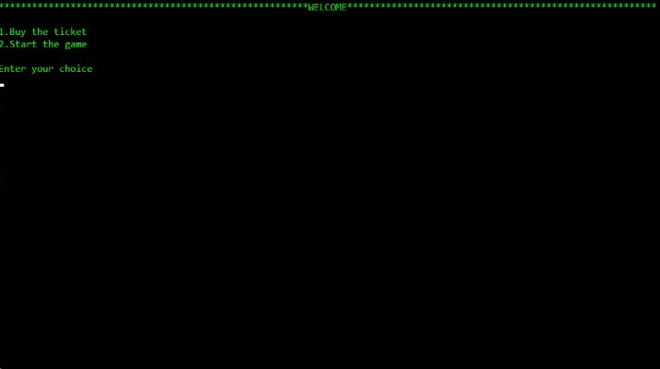

**2)Key feature**: If the player has not paid the complete amount then he/she cannot play the game until he/she pays the due amount.

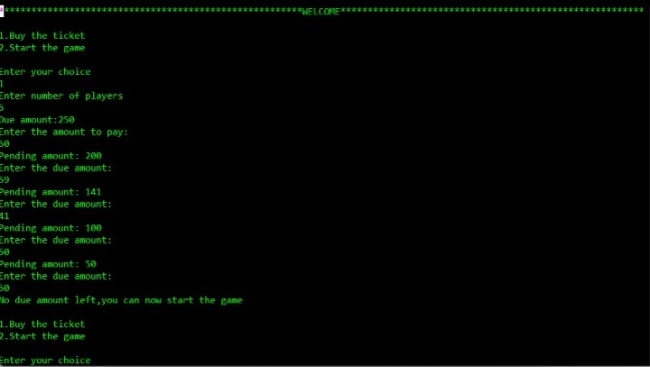

**3)** The program is so configured that if the user tries to skip the first step(buying the ticket) the program will not allow the user to proceed to next option.

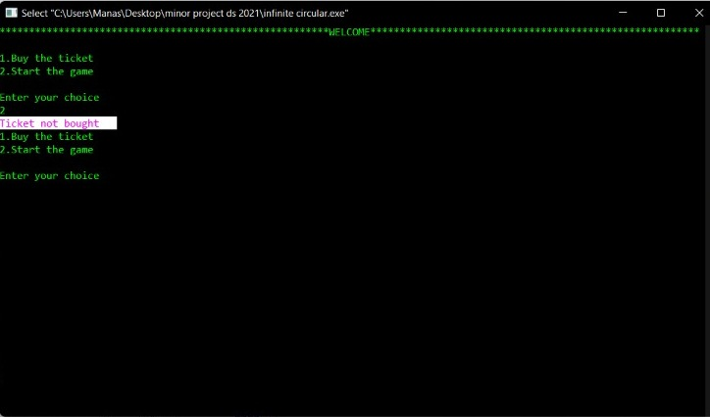

4) As the game starts, the user is asked to choose numbers to represent each player uniquely.

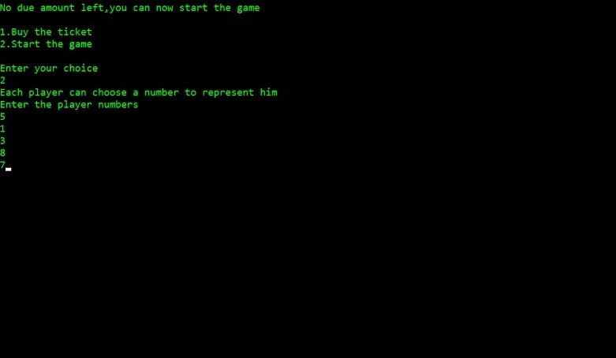

5**) Key feature**: As the circular linked list starts printing, song will start playing in the background.

**Key feature**: The program is so created that, instead of the music being dependent on for loops, it actually works for a time constraint set by the user!

We have used #include<ctime> library to add a real time clock() that would start clocking the time as soon as the loop starts.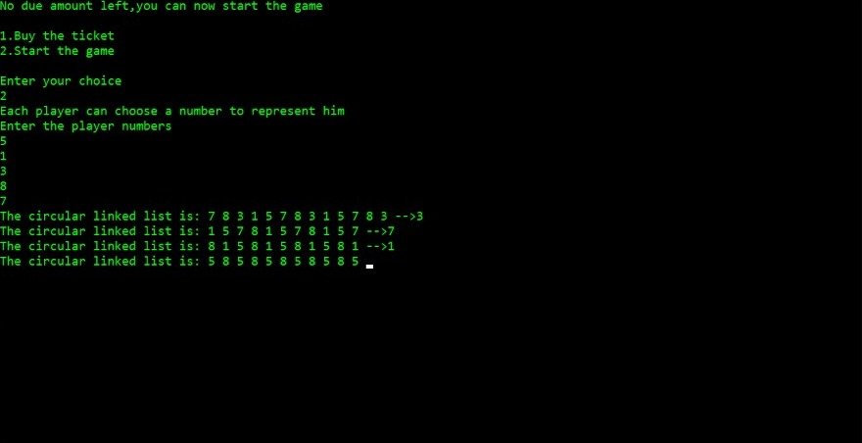

6) The output shows the circular linked list work n times, deletes the number at which the music stops, and then proceeds to run until a single winner is found.

As the elements get deleted, they are pushed in a stack, which is later displayed in the form of a leaderboard.

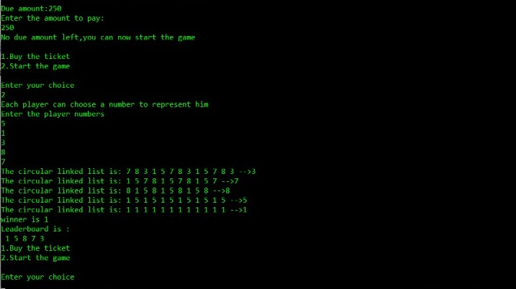

***Conclusion:***

* A first time experience in implementing data structures in a creative way.
* Applying concept of INFINITE CIRCULAR LINKED LIST including insertion and deletion.
* Implementing LIFO property of a STACK.
* Learning how to integrate and play music through the command prompt.
* Improved team work through time management.
* Learned to integrate multiple functionalities under one umbrella.
* Learned to open web browser link through C++ command prompts.

***REFERENCES:***

**[1]**. Time based loop -- https://stackoverflow.com/questions/32988697/run-c-loop-for-a-specific-time

**[2].** Sound integration -- https://www.youtube.com/watch?v=YfHquRENMUI

